EXPERIMENT 4
RAPTOR Flowchart to Count Characters in a String
Experiment 4 | RAPTOR | CO1
Objective
To design a RAPTOR flowchart that accepts a string, calculates the total number of characters in the string, and displays the result.
Algorithm
1. Start.
2. Read the string.
3. Find the length of the string.
4. Display the length.
5. Stop.
Step 1: Open RAPTOR
1. Open the RAPTOR application.
2. Click New Flowchart or start with a blank flowchart.
Step 2: Insert Start and Input Symbols
1. RAPTOR provides the Start and End symbols automatically.
2. Drag an Input symbol onto the connector between Start and End.
3. Configure the input prompt as “Enter a string:” and store the input in the variable str.
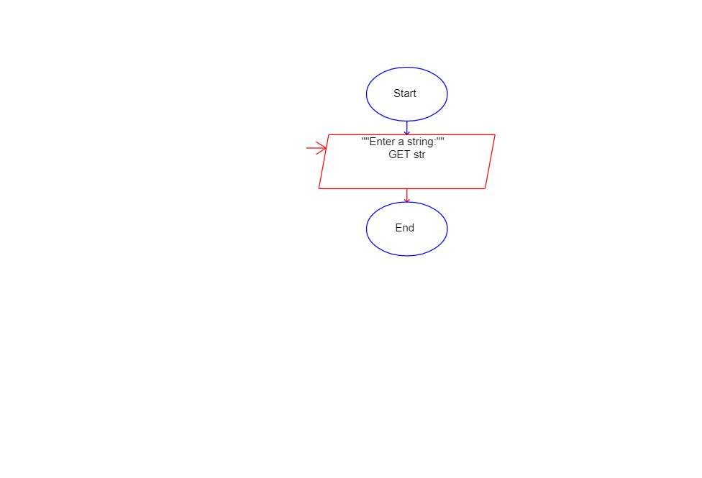
Input symbol configured to read the string variable str.
Step 3: Process to Find Length
1. Drag an Assignment symbol onto the connector after the Input symbol.
2. In the assignment dialog, set the variable name to count.
3. Set its value to Length_Of(str).
Assignment: count ← Length_Of(str)
Step 4: Display the Result
1. Drag an Output symbol after the Assignment symbol.
2. Enter the output expression exactly as shown below. Use + to join the text and the variable.
Output: "Total characters = " + count
Step 5: Final Flowchart Structure
The symbols must appear in this order:
- Start
- Input str
- count ← Length_Of(str)
- Output "Total characters = " + count
- End
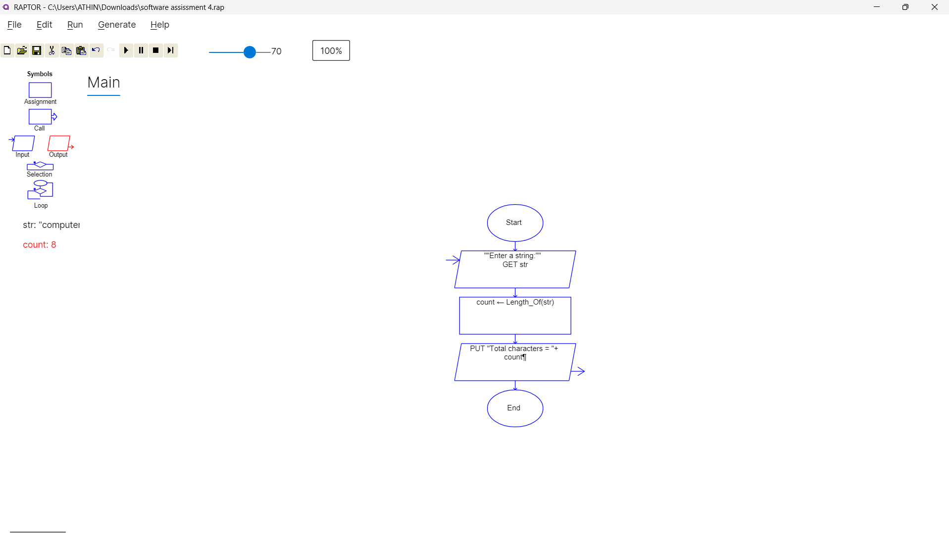
Final RAPTOR flowchart with the character count variable displayed.
Step 6: Run the Program
1. Click the Run (▶) button in RAPTOR.
2. When prompted, enter the string: Computer
3. Check the output in the RAPTOR MasterConsole.
Expected output: Total characters = 8
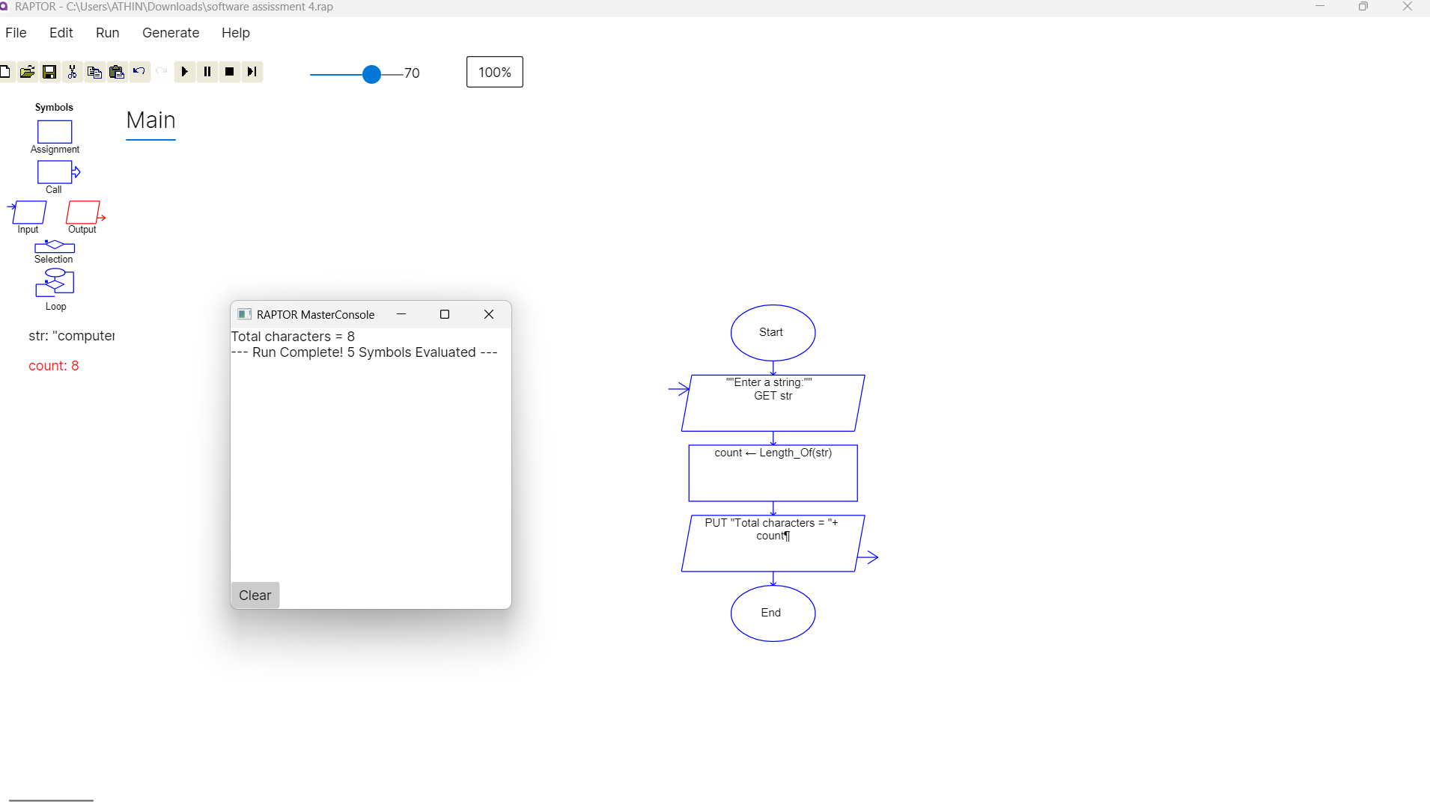
Program run completed successfully; the MasterConsole displays Total characters = 8.
Result
Thus, a RAPTOR flowchart was successfully designed and executed to calculate and display the number of characters in an input string.

